State of New Mexico
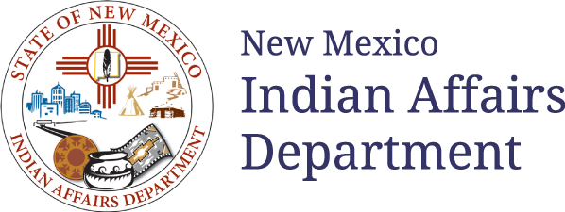

request for proposal (RFP)

#26 609 0000 00003

Amendment One
Culturally Relevant Commercial Tobacco Cessation & Prevention Services for Native American Communities in New Mexico

RFP Release Date: 11/24/2025

Proposal Due Date: 12/15/2025
Indian Affairs Department
Program Services Division
1220 S. St. Francis Drive, Suite 251, Santa Fe, NM 87505

RPF#: 26 609 0000 00005 is AMENDED as follows:
Key Revisions include but are not limited to:
- The update of the request for proposal number:

State of New Mexico

request for proposal (RFP)

#26 609 0000 00005

Amendment One
Culturally Relevant Commercial Tobacco Cessation & Prevention Services for Native American Communities in New Mexico

RFP Release Date: 11/24/2025

Proposal Due Date: 12/15/2025
Indian Affairs Department
Program Services Division
1220 S. St. Francis Drive, Suite 251, Santa Fe, NM 87505

