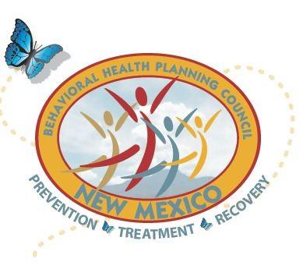
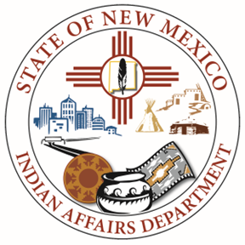
New Mexico Behavioral Health Planning Council

Native American Subcommittee (NASC) Transition

Date: October 2, 2024
Time: 10:00 am – 12:00 pm
AGENDA
10:00 am Opening prayer and Land Acknowledgement
10:10 am Welcome - Seth Damon, IAD Deputy Secretary
- IAD Updates
- BHSD Updates by Brandi Reano, Native American Liaison
- CYFD Updates by Tribal Liaison Report - TENTATIVE
- Medicaid Updates Tribal Liaison Report by Theresa Belanger, Native American Liaison
10:30 am NASC LC-Mini Summit Planning Committee/NASC Budget
11:00 am NASC Priorities discussion
Brainstorming – NASC & Community Members
11:30 am LC Updates
- LC 14 – John Tsabetsaye
- LC 15 - Noreen Kelly
- LC 16 – Rebecca Ballantine
- LC 17 - Vacant
- LC 18 – Layne Kalbfleisch
11:55 am Closing Remarks
12:00 pm Closing prayer

Meeting Ends-Thank You!

