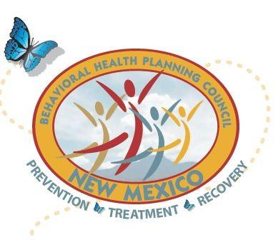
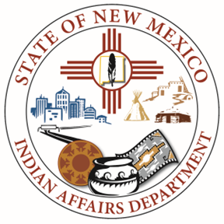
New Mexico Behavioral Health Planning Council
Native American Subcommittee (NASC)

Date: February 5, 2025
Time: 10:00 am – 12:00 pm
AGENDA
https://us06web.zoom.us/j/82318320366?pwd=sMzuQNRCXJJ48iCBmC1bEVcB6zerwL.1
Meeting ID: 823 1832 0366
Passcode: 873355
10:00 am Call to Order
Opening prayer and Land Acknowledgement
10:05 am Welcome – Carmela Quitugua, IAD
- Approval of Agenda
- Approval of Meeting Minutes
  - December 4, 2024
- IAD Updates
10:15 am IAD Legislative Updates, Amanda Nezzie, IAD Government Relations & Policy Director
Behavioral Health Bills being reviewed by Health Care Authority, List provided, Natalie Rivera, NM Behavioral Health Planning Council Liaison, HCA, BHSD
10:40 am NM American Indian Day at the Legislature, Karmela Martinez, IAD Operations Manager
10:50 am NM Behavioral Health Day, Natalie Rivera
11:05 am 2025 NASC Behavioral Health Summit, Karmela Martinez
Tentative Date, Venue, Theme, Planning Committee
11:35 am LC Updates
- LC 14 – John Tsabetsaye
- LC 15 - Noreen Kelly
- LC 16 – Rebecca Ballantine
- LC 17 - Vacant
- LC 18 – Layne Kalbfleisch
11:50 am Closing Remarks
11:55 am Next Meeting
12:00 pm Adjournment

