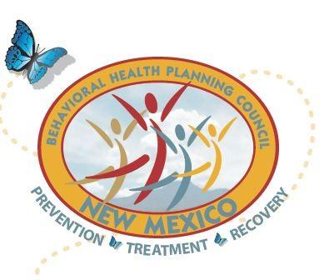
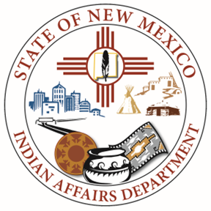
New Mexico Behavioral Health Planning Council

Native American Subcommittee (NASC)
Executive Meeting

Date: January 29, 2025
Time: 10:00 am
AGENDA
10:00 am Opening and Welcome – Carmela Quitugua, IAD
- IAD Updates
- IAD Cabinet Secretary, Josette Monette, designate chair for NASC
10:10 am NM American Indian Day at the Legislature, Karmela
10:15 am NM Behavioral Health Day, Natalie Rivera
10:20 am 2025 NASC Behavioral Health Summit and LC Retreat, Karmela
Proposed Dates, Venues, Theme, planning committee and meeting dates
10:45 am LC Items
- LC 14 – John Tsabetsaye
- LC 15 - Noreen Kelly
- LC 16 – Rebecca Ballantine
- LC 17 - Vacant
- LC 18 – Layne Kalbfleisch
10:55 am Closing Remarks
11:00 pm Closing

