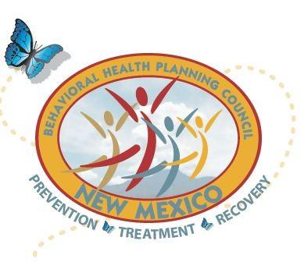
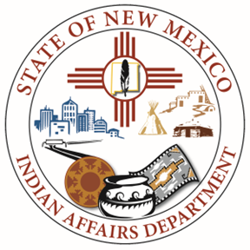
New Mexico Behavioral Health Planning Council
Native American Subcommittee (NASC)

Date: April 4, 2025
Time: 10:00 am – 12:00 pm
AGENDA
https://us06web.zoom.us/j/82318320366?pwd=sMzuQNRCXJJ48iCBmC1bEVcB6zerwL.1
Meeting ID: 823 1832 0366
Passcode: 873355
10:00 am Call to Order
10:05 am Welcome – Karmela Martinez, IAD
- Approval of Agenda
- Approval of Meeting Minutes
  - February 5, 2025
- IAD Updates
10:15 am NM Behavioral Health Bills, Annabelle Martinez, HCA
IAD Legislative Updates, Amanda Nezzie, IAD Government Relations & Policy Director
10:45 am NM Behavioral Health Day summary, Natalie Rivera
10:55 am 2025 LC Retreat & NASC Behavioral Health Summit, Karmela Martinez
SAVE THE DATE: May 15, 16, 2025, Isleta Resort & Casino
SAVE THE DATE FLYER coming soon.
Theme (TBD): Focus on strength within Our CommUNITY (communities)
11:15 am LC Updates
- LC 14 – John Tsabetsaye
- LC 15 - Noreen Kelly
- LC 16 – Rebecca Ballantine
- LC 17 - Vacant
- LC 18 – Layne Kalbfleisch
11:50 am Closing Remarks
11:55 am Next Meeting: June 4, 2025, 10:00am
12:00 pm Adjournment

