State of New Mexico
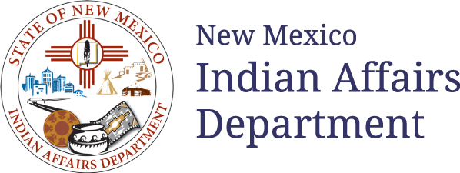

request for proposal (RFP)

#26 609 0000 00003

Amendment One
Culturally Relevant Commercial Tobacco Cessation & Prevention Services for Native American Communities in New Mexico

RFP Release Date: 10/27/2025

Proposal Due Date: 11/17/2025
Indian Affairs Department
Program Services Division
1220 S. St. Francis Drive, Suite 251, Santa Fe, NM 87505

RFP#: 26 609 0000 00003 is AMENDED as follows:
Key Revisions include but are not limited to:
- The Issue Date on the Sequence of Events has changed:

From: Original Sequence of Events: 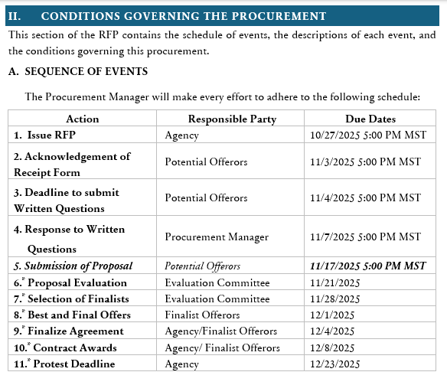.
To: Amended Sequence of Events: