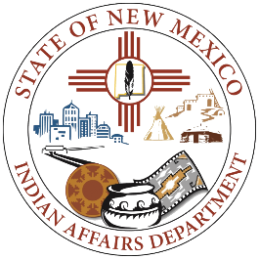
FY26 Tobacco Cessation & Prevention Project Grant Application

APPLICANT INFORMATION: Person who will be managing the award on behalf of the Applicant, this is the main point of contact for IAD.

Legal Name of Tribal Government: Click or tap here to enter text.

Name of Person, Title and Program Submitting Application: Click or tap here to enter text.
E-mail: Click or tap here to enter text.

Address: Click or tap here to enter text.

Phone number: Click or tap here to enter text.

SIGNATORY INFORMATION: Person who can legally sign contractual agreements on behalf of the Applicant

Name of Signatory: Click or tap here to enter text.

E-mail: Click or tap here to enter text.

Address: Click or tap here to enter text.

Phone number: Click or tap here to enter text.

LEGAL SUFFICIENCY INFORMATION: Person who will be reviewing contractual agreements for legal sufficiency on behalf of the Applicant.

Name of Legal Counsel: Click or tap here to enter text.

E-mail: Click or tap here to enter text.

Address: Click or tap here to enter text.

Phone number: Click or tap here to enter text.

PROJECT/SERVICE INFORMATION
Project Name (Be specific): Click or tap here to enter text.

Requested Amount (should align with IAD budget request form): $ Click or tap here to enter text.

Identify and address how Applicant will use TCPP funds to establish or expand culturally appropriate tobacco cessation and prevention initiatives and how those resources will benefit tribal communities and/or Native American people in New Mexico.
Click or tap here to enter text.

Describe how the Applicant will expend all funds by June 30, 2026:
Click or tap here to enter text.

APPLICATION CHECKLIST
☐ Application fully completed
☐ IAD Budget Request Form
☐ Letter of Support from Tribal Leadership

Signature: Date:

